

**SCHOOL OF COMPUTING AND ENGINEERING SCIENCES**

**A Web Based System for Financial Tracking and Planning**

**Student Names**: Alpha Munene and Manya George Okech

**Student Number**: 144376 and 148545

An Informatics and Computer Science Project Proposal Document Submitted to the School of Computing and Engineering Sciences in Partial Fulfillment of the Requirements for the Award of a Degree in Bachelor of Science in Informatics and Computer Science.

Submission Date: May 6th, 2024

# Declaration

We declare that this project proposal has not been submitted to Strathmore University or any other University for the award of a Degree in Bachelor of Science in Informatics and Computer Science or any other Degree.

Student Name: _________________________________________________________

Signature: _____________________________________________________________

Date: _________________________________________________________________

Student Name: _________________________________________________________

Signature: _____________________________________________________________

Date: _________________________________________________________________

Supervisor Name: _______________________________________________________

Signature: ______________________________________________________________

 Date: _________________________________________________________________

# Abstract

The economic state of a country has very many effects on the citizens of that country. Depending on whether the economic state of the country is good or bad, citizens will feel financially free for example when taking investment risks or even with their spending power or they will feel financially burden for example with an increased cost of living.

Over the past year or so, the economic environment in Kenya has been in the most unstable state it has been in over the past few years. This unstable state has burdened Kenyans with an increase in the cost of living and unsafe financial environment having to worry about individuals participating in fraud, corruption and theft.

To address this challenge, this research proposes the use of a user friendly, interactive website that aims to provide Kenyans with a safe platform to input their budgets, expenditure, financial goals and targets as well as monitor their finances and report any instances of financial misconduct in companies and organisations.

This proposal is needed in that, the economic environment has necessitated Kenyans to be more frugal with their money and on top of that, it has also forced them to be more cautious and protective over their finances. Our proposed research offers a solution that can aid these efforts.

***Keywords: Budget planning, Interactive website, Financial tracking tool, Anti-Corruption, Anti-Fraud, Target setting, Financial well-being, scrum.***

# Table of Contents

Declaration ii

Abstract iii

Table of Contents iv

List of Figures vi

List of Abbreviations vii

Chapter One: Introduction 1

1.1 Background 1

1.2 Problem Statement 2

1.3 General Objective/Aim 3

1.3.1 Specific Objectives 3

1.3.2 Research Questions 3

1.4 Justification(s) 3

1.5 Scope and Limitations 4

1.5.1 Scope of the Project 4

1.5.2 Limitation(s) of the Project 4

Chapter Two: Literature Review 5

2.1 Introduction 5

2.2 Challenges Faced 5

2.3 Existing Solutions 6

2.3.1 EveryDollar 6

2.3.2 Wallet 7

2.3.3 Ethics and Anti-Corruption Commission. 7

2.3.4 E-Citizen Platform 8

2.4 Gaps in the Existing Applications/Solutions 9

2.5 Conceptual Framework 10

Chapter Three: Development Methodology 11

3.1 Introduction 11

3.2 Software Development Methodology 11

3.2.1 Planning 12

3.2.2 Sprints 12

3.2.3 Scrum Meeting 13

3.2.4 Sprint Review and Retrospective 13

3.3 Software Requirements Analysis 13

3.3.1 Functional Requirements 13

3.3.2 Non-Functional Requirements 14

3.3.3 System Narrative 14

3.4 System Design 14

3.4.1 Use Case Diagram 14

3.4.2 Class Diagrams 14

3.4.3 Entity Relationship Diagram (ERD) 15

3.4.4 Database Schema 15

3.5 System Development Tools and Techniques 15

3.5.1 PHP 15

3.5.2 HTML 15

3.5.3 CSS 15

3.5.4 JavaScript 15

3.5.5 Bootstrap 5 16

3.5.6 XAMPP 16

3.5.7 Figma 16

3.5.8 Visual Studio Code 16

3.5.9 GitHub 16

3.6 Deliverables 16

3.6.1 System Proposal 16

3.6.2 Authentication Module 17

3.6.3 Administrator Module 17

3.6.4 Employee Module 17

3.6.5 Database 17

References 18

Appendix 21

Appendix A1: Time Schedule 21

# List of Figures

Figure 2.1: EveryDollar Sign Up Page (Source: https://www.everydollar.com) 6

Figure 2.2: Wallet Home Page (Source: https://web.budgetbakers.com) 7

Figure 2.3: EACC Landing Page (Source: https://eacc.go.ke) 8

Figure 2.4: E-Citizen Login Page (Source: https://accounts.ecitizen.go.ke) 8

Figure 2.5: Conceptual Framework Diagram (Source: https://figma.com) 10

Figure 3.1: Scrum Methodology Illustration (Source: https://startinfinity.com/project-management-methodologies/scrum) 12

# List of Abbreviations

GDP - Gross Domestic Product

CPI - Corruption Perceptions Index

CDS - Corruption Detection System

PAYE - Pay As You Earn

KRA- Kenya Revenue Authority

EACC- Ethics and Anti-Corruption Commission

# Chapter One: Introduction

## 1.1 Background

Over the past year or so, Kenya’s economy has been in the most unstable state the as a nation has witnessed in quite a few years. The Kenyan shilling has regularly free fallen with 1 USD being valued at as low as Ksh. 161 at one point, and currently being valued at Ksh. 131.21. This unpredictable, unstable economic environment has affected everyone in the country, down from the individual citizen to the family unit/household all the way up to businesses, business owners and industries.

The working class/labor force is experiencing an increase in taxes. For example, as of March 19th, 2024, the Affordable Housing Levy Act was assented into law. This Housing Act is mandatory for all employers, employees, salaried and non-salaried individuals who are required to remit a percentage of their salaries or wages. An employer is required to remit in respect of each employee the employer's contribution at 1.5% of the employee's monthly gross salary and the employee's contribution at 1.5% of the employee's monthly gross salary (Wright, 2024). The Act also incorporates non-salaried persons, who were not previously covered by the provisions that the High Court suspended. Non-salaried persons will be expected to make contributions of 1.5% of their gross income (Wright, 2024). Furthermore, penalties of 3% on unpaid amounts are levied on those who fail to remit the levy by the due date (Wright, 2024). This increase in tax will reduce employee’s disposable income, hurt purchasing power and erode business’ profits (Kerrow, 2023). Moreover, as an economic rule of thumb, with an increase in taxes comes a corresponding increase in the cost of living (Kerrow, 2023).

Each of citizen has personally been affected by the increased cost of living over the past year or so. From the price of small goods such as eggs increasing from Ksh. 15 to Ksh. 20 per egg to a shortage of Maize flour around June 2023 which led to some households stock piling on any available maize flour that they could and individuals fighting for any available maize flour they could find in stores. Furthermore, the already scarce maize flour was selling at a higher price than usual (Owino, 2023). In general, the price of household goods increased over the last year or so, food stuff, cleaning tools etc. The most noticeable change brought about by the increased cost of living however has been the regular increases in the cost of fuel. This change has affected both users of public and private transportation. Public transport users have been affected by the increase in the fare prices they use to cover distances they would usually cover for less. An example of this is how a matatu from the Safaricom headquarters along Waiyaki Way to town costs Ksh. 50 where a year or two ago the same matatu would charge one Ksh. 30. Private transport users have been affected in that, we are seeing more individuals that own cars opt to use public transport like matatus especially while covering long distances with even a few opting to use means such as Uber and Bolt which would ordinarily be the less economically viable option for someone with a car long term.

On top of the unstable economy, another major challenge facing the country has been corruption that limits the growth of both its private and public sectors. Kenyans have slowly lost trust in the system due to corruption and fraud happening in broad daylight and when discovered it’s too late to recover lost funds. Corruption in Kenya has always evolved from Goldenberg (100 billion) cost Kenya the equivalent of more than 10% of the country's annual Gross Domestic Product (GDP) of taxpayer’s money, Anglo-leasing, Eurobond up to present on going cases in court such as fertilizer scandals etc. Private sector is not any better, as such cases are common. Organizations such as NYS which have two major occurrences of corruption, 791 million and 9 billion respectively, what is preventing a third occurrence from happening?

## 1.2 Problem Statement

The economic state and environment of a country has a very big effect on the cost of living its people have to endure, the level of tax they must remit to the government among other financial burdens. Over the past year or so, the Kenyan economy has been in the most unstable state the country has had to face in quite a while bringing along with it a high cost of living as well as opportunists who take advantage of individuals through fraud, corruption and even theft. Due to this, there is a need for Kenyans to be more frugal and protective over their finances and how they use them. Therefore, there is a need for a website that serves as a platform for Kenyans to budget, track and protect their finances.

## 1.3 General Objective/Aim

To develop a web-based system that provides a platform for tracking and monitoring of finances.

### 1.3.1 Specific Objectives

1. To review existing financial planning and anti-corruption tools.
2. To identify challenges faced by individuals in running businesses or managing their personal finance.
3. To design, develop and test a web application that provides a platform for tracking and monitoring finances with ease.

### 1.3.2 Research Questions

1. What are the existing solutions in financial planning and anti-corruption?
2. What are the challenges faced by individuals in running businesses or managing their personal finance?
3. What are the best tools used when designing a web-based system?
4. What are the best development methodologies that can be used to develop a web-based system?
5. How can the proposed web-based system be tested to ensure all modules are functional?

## 1.4 Justification(s)

The vast majority of people, unfortunately, are not financially literate. Due to this fact, budgeting, payment tracking, analyzing etc, can seem like a very daunting and difficult task. Many financial tracking applications and systems overlook this fact and hence, bombard their users with a multitude of features and tools that are not quite intuitive to use and take time to grasp/understand. This is a major reason that would deter users from using such a system. Furthermore, there exist financial tracking systems with complicated User Interfaces. A complicated/difficult to use interface makes the already daunting task of handling a finance management system seem like a much larger hurdle to get over than it already was. The proposed system aims to cater to these issues. The proposed system’s aim is to develop a simple, intuitive and user-friendly interface that can be used by computer savvy individuals as well as people who lack vast knowledge and experience interacting with computers. On top of this, provide simple tools that can cater to the needs of all the system users with a gentle learning curve.

## 1.5 Scope and Limitations

### 1.5.1 Scope of the Project

The proposed web-based system targets individuals, households and businesses in Kenya. The proposed system will mainly allow users to input a budget over a self-specified duration of time as well as their expenditure over the set time period. The system will then cross analyses the budget against the user’s expenditure with the help of a graph. Furthermore, for businesses, employees will be required to provide receipts/payment statements that the administrator can use to cross reference with the trends on the graph.

The proposed system will not directly link to accounts such as Mpesa or Mobile Banking Applications, users will be required to input their expenditure manually in a simplified process for example through screenshots or pictures.

### 1.5.2 Limitation(s) of the Project

The proposed web-based system’s use is limited to areas with Wi-Fi connectivity, devices that can connect to the internet and areas with electricity.

# Chapter Two: Literature Review

## 2.1 Introduction

This chapter discusses the challenges faced by individuals who set out to manage their finances either personal, household or business’. Furthermore, it reviews existing methods, technologies and applications used by the specified groups above to aid on their financial management journey.

## 2.2 Challenges Faced

There are many challenges faced when using the existing solutions of financial planning and anti-corruption, one of which is manually planning and tracking finances for example using logbooks. This method is very prone to human error for example, when dealing with large data sets such as in organizations it is very common to make errors like misspelling or truncation etc. It is time consuming to account for numerous expenditures from data entry to reconciling accounts as well as searching for old records and statements, the process can take up a lot of your time. It is static and does not offer insight to real time changes of information (King, 2022). It more often than not is based on raw numbers and figures which can be difficult or time consuming to make sense of as compared to visual aids like pie charts or line graphs that are more intuitive to read and more easily help reveal patterns and new valuable insights into the data that might not be as noticeable in raw, numerical form providing an ability to quickly recognize and understand these patterns which can lead to faster decision-making, saving time and resources (Deloitte, 2023).

Another challenge faced by the existing solutions to the problem described is the use of jargon in financial planning applications. The use of jargon caters to financially literate and competent individuals and singles out those who are not. For example, the ordinary “mama-mboga” for instance may not know the implications of something like profit margins etc. Studies show that cross-country differences in financial inclusion can be attributed to language heterogeneity i.e., combinations of different languages (Campbell, 2003). The literature in economics presents language as one of the most important dimensions of non-economic institutions determining economic outcomes of individuals and affecting important resource-allocation decisions (Chi, Su, Tang, & Xu, 2020). These studies show how language can affect one’s decision making especially when it comes to matters concerning finance like in the case of jargon.

Lastly, anti-corruption solutions and applications that are currently in the market audits detect corruption after it has already taken place. Furthermore, manual systems such as whistle blowers are compromised and threatened hence not effective since it has cost people their freedom and others their lives.

## 2.3 Existing Solutions

### 2.3.1 EveryDollar

EveryDollar is a budgeting app that helps people budget with confidence, track transactions, and get insight into their spending and saving habits (RamseySolutions, 2024). The main target audience is individuals, and it offers a very interactive step by step setup process for individuals who have just signed in, implementing icons and graphics to aid with their prompts that vary from the user’s different monthly incomes, allowing them to specify whether they have one, two or more sources of income. Additional prompts include monthly expenditure such as rent payments, electricity costs, water etc. The setup process is very smooth, interactive and thorough, making sure they acquire all the information necessary. The last pro is their interface, it’s very simple, the colors don’t clash and it does not bombard individuals with a lot of analytical information on first glance.

A con of EveryDollar worth mentioning is the fact that most of the features are made available to individuals subscribed to their premium package e.g., linking one’s bank accounts to the application meaning free users have to input their transactions manually among other limitations.

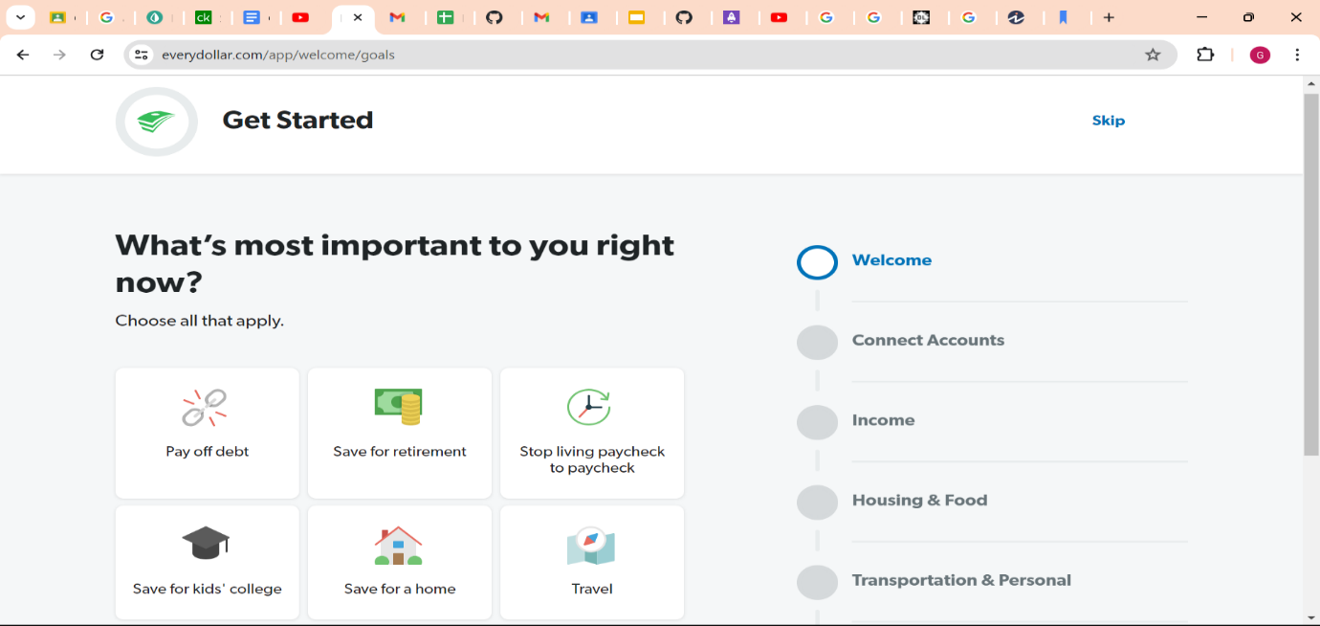

Figure 2.1: EveryDollar Sign Up Page (Source: https://www.everydollar.com)

### 2.3.2 Wallet

Wallet is a budgeting application by BudgetBakers is a finance manager that lets one know how they spend and helps them save to achieve their goals (budgetbakers, 2022).It allows users to come up with a budget and monitor their expenditure. Before one’s account is fully setup, the intending user is prompted to state the current amount they have in at least one of their accounts or wallet etc, with an option to add additional accounts after setup is complete. As compared to EveryDollar, Wallet prompts users less information hence is less thorough but alternatively, their interface is more minimalistic providing a graph on the dashboard that displays the trend in their expenditure as well as an option to view their spending in previous months. It is a very clean and neat application. It also provides a version for business owners with additional features.

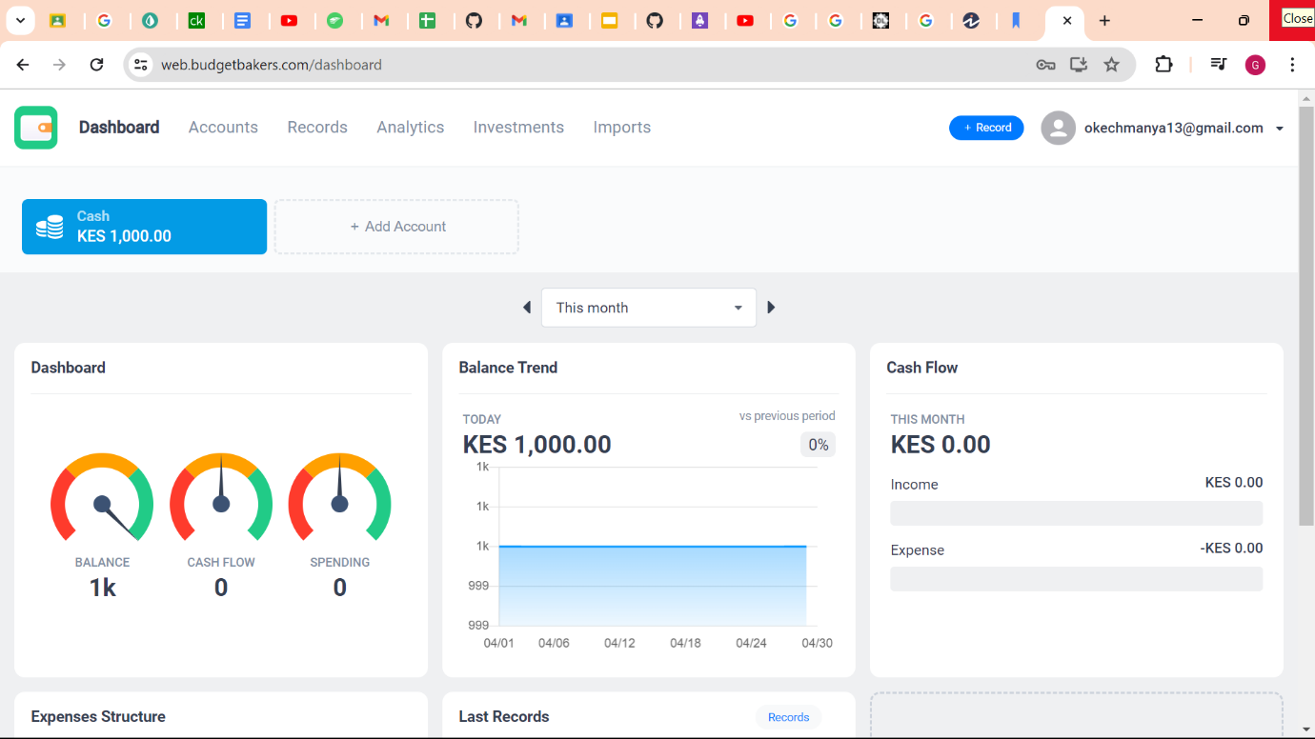

Figure 2.2: Wallet Home Page (Source: https://web.budgetbakers.com)

### 2.3.3 Ethics and Anti-Corruption Commission.

This is an application created by the Ethics and Anti-Corruption Commission's (EACC) under the Kenyan Government to enable people to access the EACC digital services.

Under the EACC, exists Adili webpage that offers services such as self declarations for applicants seeking appointment or election to public office or other employments. Accounts record keeping for all state and public officers operating bank accounts in Kenya. Other services include reporting corruption portal, codes of conduct portal, gift declaration and conflicts of interest.



Figure 2.3: EACC Landing Page (Source: https://eacc.go.ke)

### 2.3.4 E-Citizen Platform

It is a web application that aims in digitizing many government services to reduce corruption cases in collection of revenue by the Kenyan government. All the revenue is collected on one platform reducing confusion, chances of error and fraud cases. Examples of payments collected include driving test fees, parking fees, passport processing fee, business permits, park fees, land survey forms etc. This replaces the old method of manually collecting money and has seen KRA collect 2.166 Trillion in FY 2022/23 more 0.135 Trillion in FY 2021/22 (Statista, 2024).In the past, collected revenue would be lost and find its way in individual’s bank accounts reducing the government’s potential in performing its duties. This set a record for the highest revenue collected. E-Citizen use a National Identity Card Number to uniquely identify its citizens and an Alien Identity Card Number to identify foreigners, making it easy to track revenue collection.

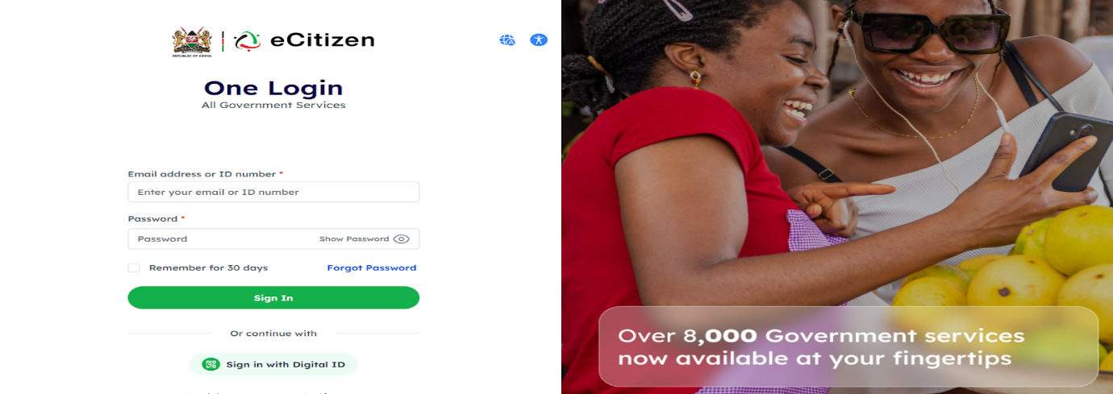

Figure 2.4: E-Citizen Login Page (Source: https://accounts.ecitizen.go.ke)

## 2.4 Gaps in the Existing Applications/Solutions

The existing solutions discussed are EveryDollar, Wallet by BudgetBakers, Adili and E-Citizen. All the stated applications provide good features, interfaces and user experiences. However, they have their limitations like all things do. Our proposed system aims to implement the pros of these applications and try minimize the cons.

In the case of EveryDollar, the major con noticed is the limited number of features for individuals that opt to use the free version. The proposed system will aim to provide all its intended features to all users that choose to use it.

In the case of Wallet, the major con is its lack of thoroughness when prompting for user’s information during its setup. The proposed system will aim to retrieve as much information about its user’s financial responsibilities as possible.

A con both these applications have is the assumption that the user is an individual opting for a personal financial management solution. The proposed system will aim to identify whether users are individuals, households or businesses.

In the case of E-Citizen, it only focuses on collection of revenue which it has saved billions of taxpayer’s money from the pockets of corrupt people. It is not concerned with the expenditure where the most corruption and fraud happens.

Adili web page under the EACC is only meant for state officials wanting public office and not the common “mwananchi". Other software exists such as Microsoft Anti-corruption software (only meant for governments), integrity app etc. hence difficulty to integrate to businesses, organizations and personal use.

## 2.5 Conceptual Framework

Below is a visual aid that summarizes the conceptual framework.

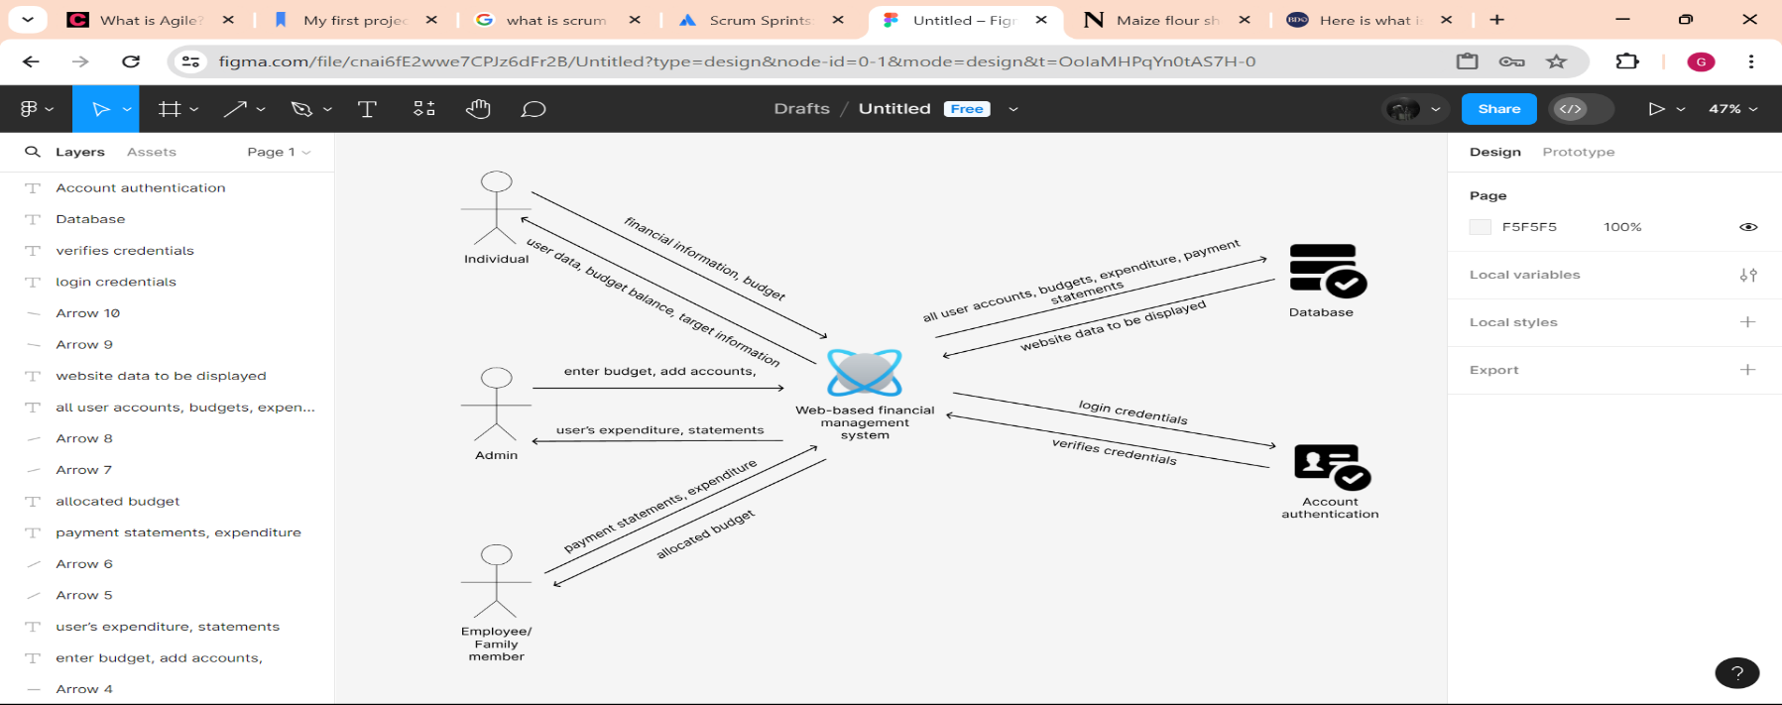

Figure 2.5: Conceptual Framework Diagram (Source: https://figma.com)

The proposed system will have three types of users: individual/personal in the case of personal accounts, family members/ employees and administrators. In the case of a personal account, the individual will act as the admin of their account. An administrator has full control of the system. They will be able to input and view the full budget and balance, they will be able to register/add and deactivate accounts for example, a household admin can register accounts for their family members and a business admin will be able to add employee accounts to the system as well as other administrators. Once an account is deactivated, they will no longer be able to login. The administrator will then be able to allocate a portion of the total budget to the users of the accounts that he/she registers. A registered user in the case of households and businesses can only see their allocated budget, not the total available budget. Additionally, they will be able to see a visual representation of their expenditure against their budget in the form of a graph. Registered users will be able to input their expenditure as well as receipts, bank statements or MPESA confirmation codes, mandatory for employees and optional for household members. Employees will be able to anonymously report instances of corruption directly to the administrator as part of the anti-corruption policy. All users will also be able to input targets and goals and will be able to view their progress towards achieving their set targets. As well as using provided tools to calculate PAYE, profits, losses etc.

# Chapter Three: Development Methodology

## 3.1 Introduction

This chapter discusses the software development methodology and the different aspects of the system analysis and design. Additionally, this section highlights the tools and techniques that will be used in the system development and the expected system deliverables that will be presented at the end of the system’s development.

## 3.2 Software Development Methodology

The Agile methodology will be used for the development of the proposed system specifically, its subset known as scrum. Agile software development refers to a group of software development methodologies based on iterative development, where requirements and solutions evolve through collaboration between self-organizing cross-functional teams (CPrime, 2024). Scrum is a subset of Agile. It is a lightweight process framework for agile development, and the most widely used one (CPrime, 2024).

Scrum has iterative cycles with the stakeholders of the system, which makes it easy to integrate changes during ongoing development (Stormi, 2019).The rationale behind selecting the scrum methodology is that it enables teams to constantly improve quality due to constant feedback that is used to refine the system so that it may fulfil all requirements. Moreover, scrum is a good development methodology for small teams.

The most basic unit of Scrum is the Scrum Team, which consists of 3 members: the Scrum Master, the Product owner and the Development team. The Scrum Master is responsible for enforcing the scrum rules and helping everyone understand Scrum theory and practice, both within the Scrum Team and the organization. The Scrum Master is responsible for the team’s effectiveness and removing impediments and is therefore the leader. The Product Owner represents the user and is accountable for maximizing the value of the product resulting from the work of the Scrum Team. This is done by ordering backlogs, creation and clear communication of product backlog items, ensuring that the product backlog is transparent, visible and easily interpretable etc. The development team is responsible for implementing the system, adapting their plan each day toward the Sprint Goal and creating a plan for sprints and sprint backlogs to attain sprint goals (Schwaber & Sutherland, 2020).

The scrum methodology can be represented as shown.

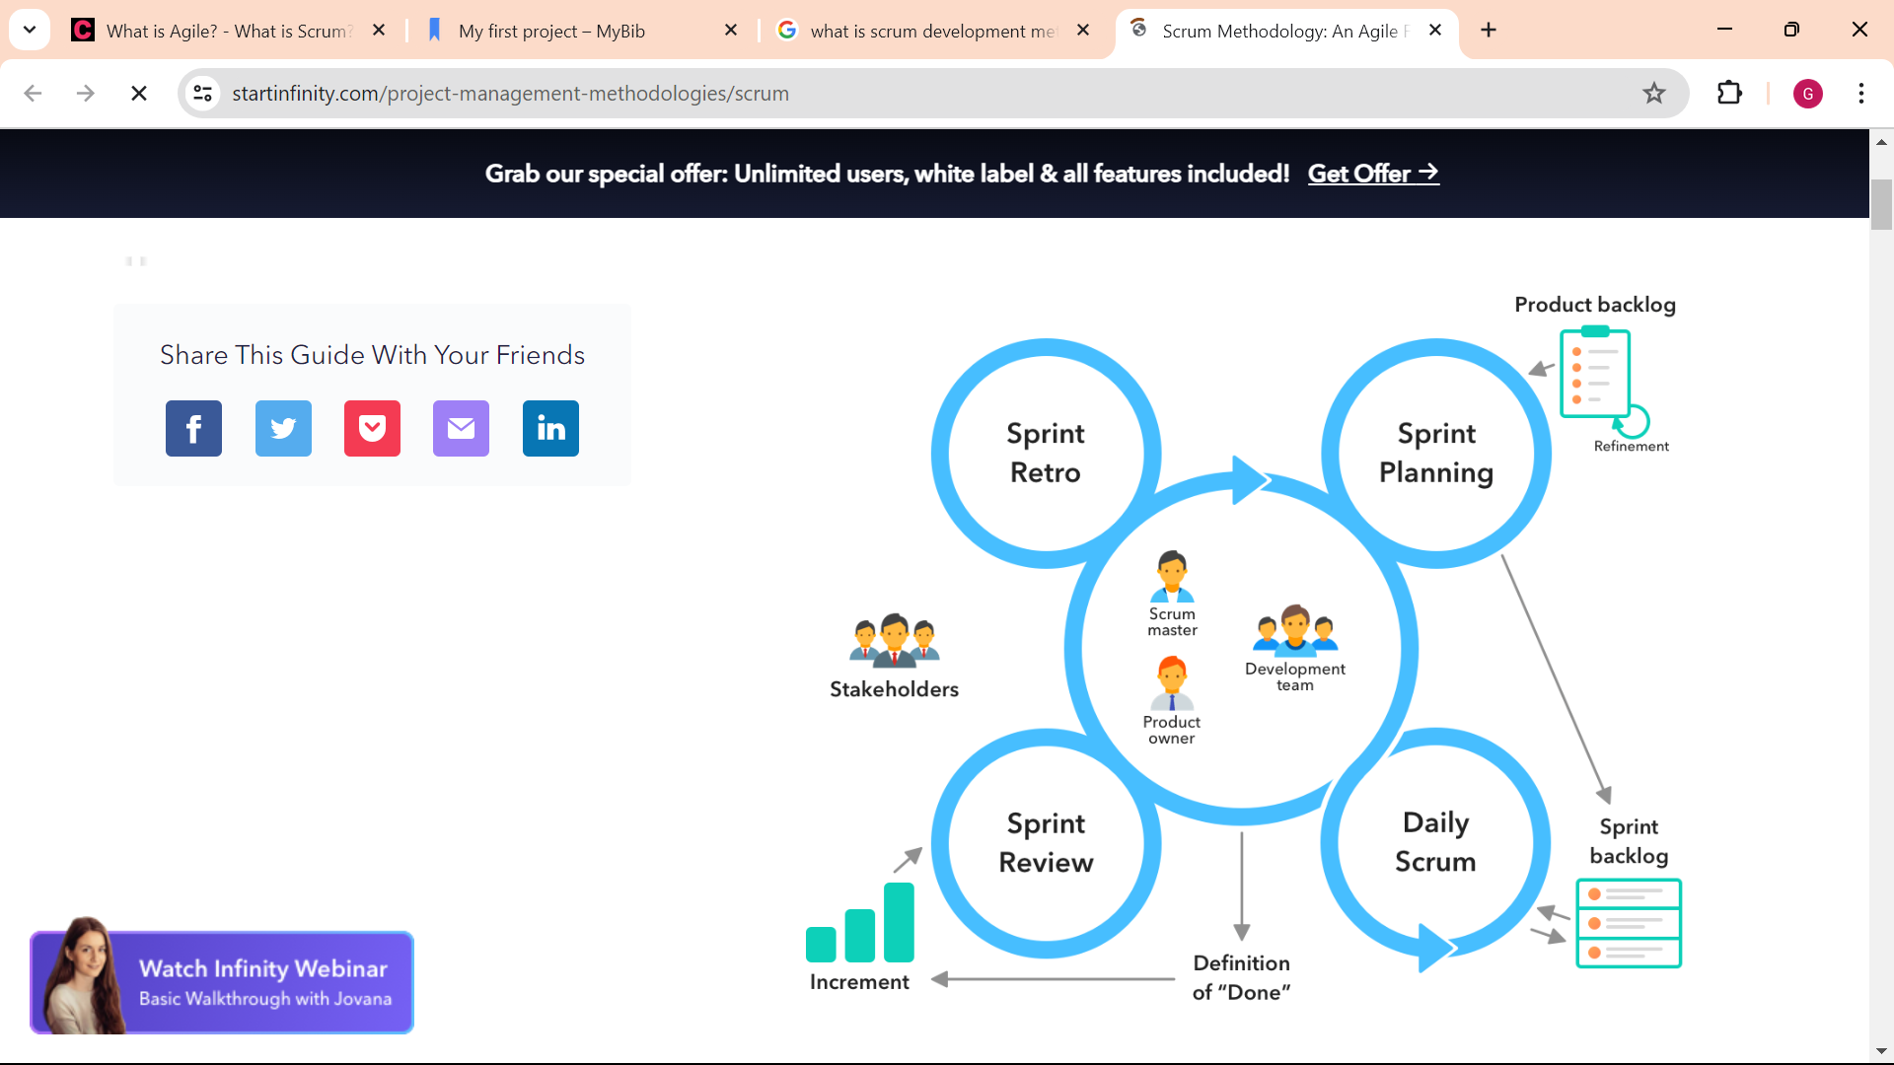

Figure 3.1: Scrum Methodology Illustration (Source: https://startinfinity.com/project-management-methodologies/scrum)

The Scrum methodology employs the use of several cyclical and iterative phases which are defined below.

### 3.2.1 Planning

In this first phase, the product backlog is defined by the Product owner and contains a description of all the system requirements. This is accompanied by an estimate of the schedule. Conceptualization and analysis also occur in this stage (Popli & Chauhan, 2011). This is the only non-iterative phase.

### 3.2.2 Sprints

These are short bursts of time within which implementation occurs. This phase involves the development of new release functionality, with constant respect to the variables of time, requirements, and quality. There will be multiple, iterative development sprints, or cycles, used to evolve the system. In this stage, the team works on implementing the sprint backlog with the aim of achieving the sprint goal. During the sprint period, the product backlog is redefined, and the project scope is reconsidered and clarified with the Product Owner as the team learned more about the system. Through sprints, there will be confirmation of completing the implementation of each system iteration (Schwaber & Sutherland, 2020). Given the constraints of this project, scrum will be well suited as the methodology of choice because it progressively produces a functional part of the final system in each sprint that is tested and assessed.

### 3.2.3 Scrum Meeting

This is a frequently held meeting, sometimes daily, by the development team in between sprints. Its purpose is to evaluate the team’s progress towards the sprint goal and accordingly adjust upcoming tasks in the sprint backlog (Schwaber & Sutherland, 2020).

### 3.2.4 Sprint Review and Retrospective

This review follows each sprint. The teams present the iterations of the sprint requirements, review progress, raise issues and resolve them or add new backlog items. The next sprint is sought after completion. The retrospective, the final part, aims at increasing effectiveness of the subsequent sprints by analysing the previous sprint’s challenges and looking into improvements that can been made (Schwaber & Sutherland, 2020).

## 3.3 Software Requirements Analysis

Software requirements analysis is a process of determining the needs and expectations of a system or software (SimpliLearn, 2020).

### 3.3.1 Functional Requirements

Functional requirements are statements of services the system should provide, how the system should react to particular inputs and how the system should behave in particular situations.

The system will allow users to input their budget.

The system will allow users to input their expenditure.

The system will display a graph to the user allowing them to visually cross-reference their expenditure against their budget.

The system will allow administrators to view other accounts details such as expenditure etc.

The system will alert users whether they are within budget or close to exceeding it using different colours i.e, green and red respectively.

The system will update the available balance left in the budget after each expenditure.

### 3.3.2 Non-Functional Requirements

System properties & constraints on the services or functions offered by the system that often apply to the system as a whole rather than individual features or services.

Business employees will have to provide receipts or statements after each expenditure.

User accounts added by administrators cannot see the fully available budget.

### 3.3.3 System Narrative

The proposed system is a web-based system meaning it is an application that can be accessed via the internet. The purpose of the proposed system is to provide people, households and businesses with a way of managing their money. By managing money it allows, budgeting to make sure people do not spend more money than they should, tracking financial goals to make sure our users are aware of whether or not they are meeting their own financial goals, protecting money by placing mechanisms against corruption and fraud like anonymous reporting amongst others and also, promoting financial discipline and accountability by allowing people to input their purchases and see how their spending habits either benefit or harm them when it comes to their finances.

## 3.4 System Design

While system analysis outlined what the system will be able to do, system design focuses on how this will be accomplished to fulfil the requirements. This will be illustrated using the following:

### 3.4.1 Use Case Diagram

A use case diagram is a diagrammatic representation of how different users interact with a system or software. For example, in the proposed system, users will be able to sign up and login, the system will verify the users, administrators can view user information like expenditure, individuals can input their budgets among others.

### 3.4.2 Class Diagrams

A class diagram depicts as static view of an application. It shows the object classes and relationships involved in a use case diagram. The class diagram is used to model the relationship between the classes in the system.

### 3.4.3 Entity Relationship Diagram (ERD)

An ERD is a design diagram used to illustrate how entities such as people, objects or concepts relate to one another within a system. ERDs are often used to design or debug relational databases. Entity Relationship Diagrams, as the name suggests, focus on the relationships of elements within certain entities rather than the relationships between entire entities themselves. It will be used to show how entities such as admins and employees etc, relate with each other.

### 3.4.4 Database Schema

A database schema defines how data is organized within a relational database. It explains the architecture of the different database relations. The database schema was used in building the actual database as every data entry will contain the properties specified in the schema (Kopecky, 2020).

## 3.5 System Development Tools and Techniques

The following will be used in the development of the proposed solution:

### 3.5.1 PHP

PHP is an open-source server-side scripting language especially suited for development for the web and can be embedded into HTML (ThePHPGroup, 2019). This made PHP the perfect language to implement the server side of the web-based solution in.

### 3.5.2 HTML

HTML is markup language used to create functional web pages by defining various elements that should be presented to the user. It’s used to give structure and meaning to web content (Mozilla, 2019). This is the language will be used for part of the frontend development.

### 3.5.3 CSS

CSS is a [stylesheet](https://developer.mozilla.org/en-US/docs/Web/API/StyleSheet) language used to describe the presentation of a document written in [HTML](https://developer.mozilla.org/en-US/docs/Web/HTML) or [XML](https://developer.mozilla.org/en-US/docs/Web/XML/XML_introduction). CSS describes how elements should be rendered on screen, on paper, in speech, or on other media (Mozilla, 2019).

### 3.5.4 JavaScript

JavaScript is a scripting language that can allow dynamic creation of websites and pages (Mozilla, 2019).

### 3.5.5 Bootstrap 5

Bootstrap is a powerful framework that is used to develop fast, responsive sites. It’s a frontend toolkit that can bring projects to life using powerful JavaScript plugins (Otto, 2022).

### 3.5.6 XAMPP

XAMPP is a free and open-source cross-platform web server solution stack package developed by Apache Friends, consisting mainly of the Apache HTTP Server, MariaDB database, and interpreters for scripts written in the PHP and Perl programming languages. It is a very popular PHP development environment (ApacheFriends, 2022). It will function as the server for the proposed system.

### 3.5.7 Figma

A collaborative design tool used for designing, prototyping and building meaningful products. This will be used in the design process of the system (Figma, 2024).

### 3.5.8 Visual Studio Code

Visual Studio Code is a code editor redefined and optimized for building and debugging modern web and cloud applications (Microsoft, 2024). It is a source code editor that will be used for development operations like debugging, task running and version control because it can be integrated with GitHub.

### 3.5.9 GitHub

A collaborative software that will be used for version control (GitHub, 2024). Each member’s contributions and source code can be displayed here and a well described markdown file is added in order to guide users on how to install and use the application.

## 3.6 Deliverables

This section discusses the different modules that will be developed in the proposed solution such as:

### 3.6.1 System Proposal

A system proposal document is an initial document that outlines the processes from project conception to implementation of the proposed system. The system proposal provides a roadmap of all activities that will be undertaken to develop the system, as well as the tools and techniques that will be used.

### 3.6.2 Authentication Module

The Authentication Module will control access to the system through a login portal to ensure only registered users have access. This module is required to distinguish between administrators and other users like employees and children in household accounts etc. with access to the system and only serve them with the relevant content and functionality.

### 3.6.3 Administrator Module

This module provides all functionality of an administrator. Including, registration of all employees, family members, other admins etc into the system, as well as deletion, viewing user expenditure etc. The admin is also able to de-register(delete) users.

### 3.6.4 Employee Module

This module will provide all functionality of a registered employee would be able to log in and at any time input their expenditure, as well as corresponding payment statements like receipts and view their expenditure history against their allocated budget.

### 3.6.5 Database

A database will be constructed to enable all the data required for the system to function to be persistently stored. It will also allow the data to be retrieved by the system when a user requests for it.

# References

2023 Corruption Perceptions Index - Explore Kenya’s results. (2024, January 30). Retrieved from Transparency.org website: <https://www.transparency.org/en/cpi/2023/index/ken>

Apache Friends. (2022). XAMPP Installers and Downloads for Apache Friends. Retrieved from www.apachefriends.org website: <https://www.apachefriends.org/>

budgetbakers. (2022, May 10). Wallet by BudgetBakers - Your New Personal Finance Manager. Retrieved from Wallet by BudgetBakers - Your New Personal Finance Manager website: <https://budgetbakers.com/>

Campbell, L. (2003). Campbell History of linguistics. *Www.academia.edu*. Retrieved from <https://www.academia.edu/29812869/Campbell_History_of_linguistic>

Chi, J., Su, X., Tang, Y., & Xu, B. (2020). Journal of Corporate Finance | ScienceDirect.com by Elsevier. Retrieved from www.sciencedirect.com website: <https://www.sciencedirect.com/journal/journal-of-corporate-finance>

CPrime. (2024, May 1). What is AGILE? - What is SCRUM? - Agile FAQ’s. Retrieved from Cprime website: <https://www.cprime.com/resources/what-is-agile-what-is-scrum/#:~:text=Agile%20software%20development%20refers%20to%20a%20group%20of%20software%20development>

Deloitte. (2023). The Five Benefits of Data Visualization. Retrieved from Deloitte Netherlands website: <https://www2.deloitte.com/nl/nl/pages/tax/articles/bps-the-five-benefits-of-data-visualization.html>

Figma. (2024). Figma: the Collaborative Interface Design tool. Retrieved from Figma website: <https://www.figma.com/>

GitHub. (2024). GitHub. Retrieved from GitHub website: <https://github.com/>

Kerrow, B. (2023, November 14). Here is what is wrong with the Kenyan economy. Retrieved from Business Daily website: <https://www.businessdailyafrica.com/bd/data-hub/here-is-what-is-wrong-with-the-kenyan-economy--4433806>

King, Z. (2022, May 18). The Shortcomings of Manual Accounting (And Why You Need to Avoid Them). Retrieved from SunAccounts website: <https://sunaccounts.com/manual-accounting-shortcomings/>

Kopecky, C. (2020). What are database schemas? 5 minute guide with examples. Retrieved May 1, 2024, from Educative website: <https://www.educative.io/blog/what-are-database-schemas-examples#what>

Microsoft. (2024). Visual Studio Code. Retrieved from Visualstudio.com website: <https://code.visualstudio.com/>

Mozilla. (2019, June 26). CSS: Cascading Style Sheets. Retrieved from MDN Web Docs website: <https://developer.mozilla.org/en-US/docs/Web/CSS>

Ojijo, M. (2019, June 1). A history of corruption and why it is ingrained in Kenyans’ DNA - Business Today Kenya. Retrieved May 2, 2024, from Business Today website: <https://businesstoday.co.ke/a-history-of-corruption-and-why-it-is-ingrained-in-kenyans-dna/>

Otto, M. (2022). Bootstrap. Retrieved from Getbootstrap.com website: <https://getbootstrap.com/>

Popli, R., & Chauhan, N. (2011). SCRUM: AN AGILE FRAMEWORK. *International Journal of Information Technology*, *4*(1), 147–149. Retrieved from <http://csjournals.com/IJITKM/PDF%204-1/30.Rashmi%20Popli1%20&%20Naresh%20Chauhan2.pdf>

Ramsey Solutions. (2024). EveryDollar | Make a Budget and Track Expenses. Retrieved from Ramsey Solutions website: <https://www.ramseysolutions.com/ramseyplus/everydollar>

Samwel Owino. (2023, June 23). Maize flour shortage looms, Cereal Millers Association warn. Retrieved May 1, 2024, from Nation website: <https://nation.africa/kenya/business/maize-flour-shortage-looms-cereal-millers-association-warn-4280314>

Schwaber, K., & Sutherland, J. (2020, November). Scrum Guide. Retrieved from Scrumguides.org website: <https://scrumguides.org/scrum-guide.html>

SimpliLearn. (2020, December 1). What Is Requirement Analysis: Applications, Techniques & Tools Used. Retrieved from Simplilearn.com website: <https://www.simplilearn.com/what-is-requirement-analysis-article>

Statista. (2024). The Statistics Portal for Market data, Market Research and Market Studies. Retrieved from Statista.com website: <https://www.statista.com/>

Stormi, K. T., Laine, T., & Korhonen, T. (2019). Agile performance measurement system development: an answer to the need for adaptability? *Journal of Accounting & Organizational Change*, *15*(2), 231–256. <https://doi.org/10.1108/jaoc-09-2017-0076>

The PHP Group. (2019, April 4). PHP: Hypertext Preprocessor. Retrieved from Php.net website: <https://www.php.net/>

Wright, C. (2024, March 21). Kenya assents Affordable Housing Levy Act, 2024, into law with immediate implications for employers/employees. Retrieved from globaltaxnews.ey.com website: <https://globaltaxnews.ey.com/news/2024-0662-kenya-assents-affordable-housing-levy-act-2024-into-law-with-immediate-implications-for-employers-employees#:~:text=Imposition%20of%20Affordable%20Housing%20Levy>

# Appendix

## Appendix A1: Time Schedule

